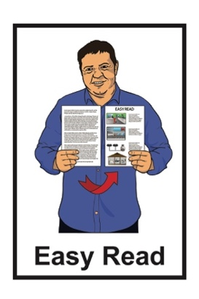


ASID Aotearoa New Zealand conference information
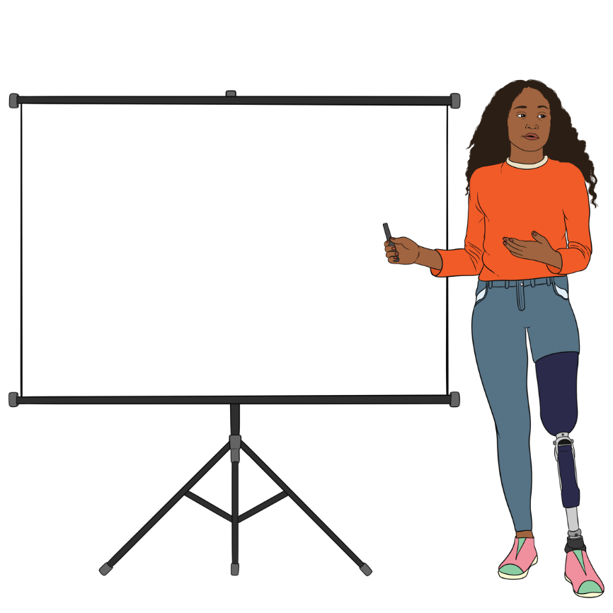

Wellington 2025

Sponsors

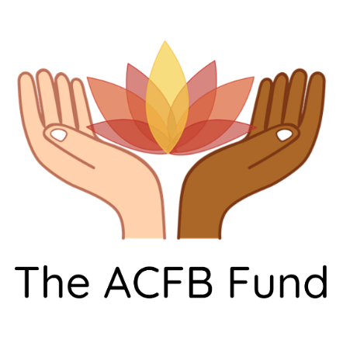
Thank you to these people for supporting the ASID conference:

The A Change for Better Fund
IHC
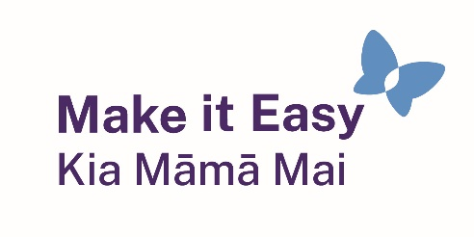
Make it Easy Kia Māmā Mai

SPQ Limited Advance


Webcare.

About the ASID conference

ASID is short for the Australasian Society for Intellectual Disability.

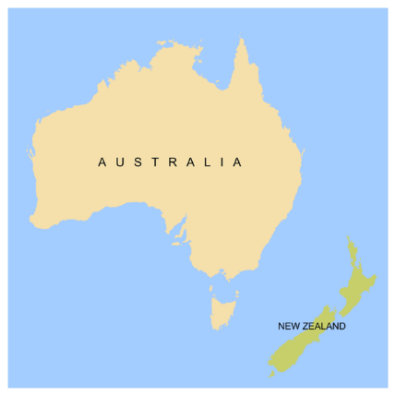
Australasian means:
Australia
Aotearoa New Zealand.
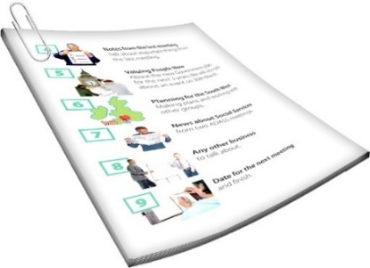

When we say we in this Easy Read we mean ASID.

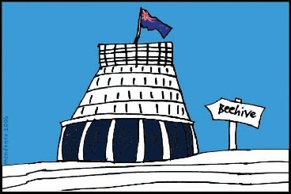
We are holding a conference in Wellington.

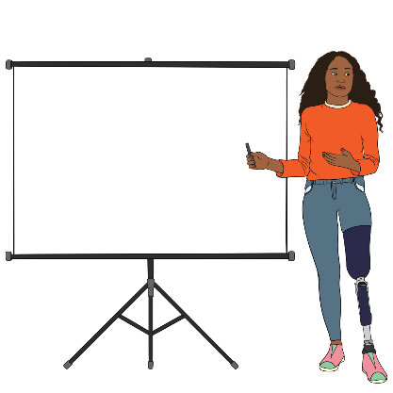
A conference is where people give talks about things they:
are doing
have found out.

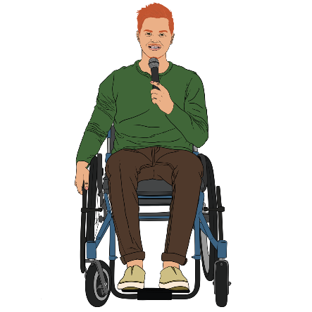
This Easy Read gives you information about the conference like:
where it is
how to get there.

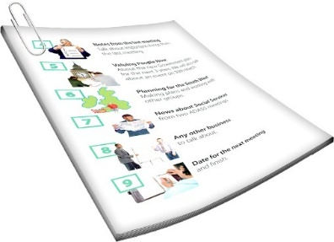
There is another Easy Read with information about the conference like:
what the talks will be about
who will be speaking.


You can find this Easy Read at:

https://bit.ly/4gyr0RG

When is the conference?


The conference is on
Monday 17 March 2025.

The venue will open at 8:30 in the morning.
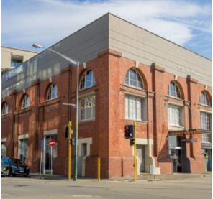

The venue is the place where the conference happens.


The conference will finish at 4:40 in the afternoon.

Where is the conference?

The conference is at the Harbourside Function Venue in Wellington.

The Harbourside Function Venue is also called Shed 22.

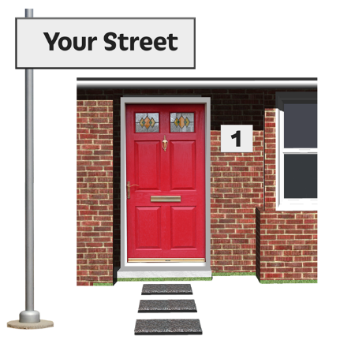
The address of Shed 22 is:

4 Taranaki Street
Wellington City.
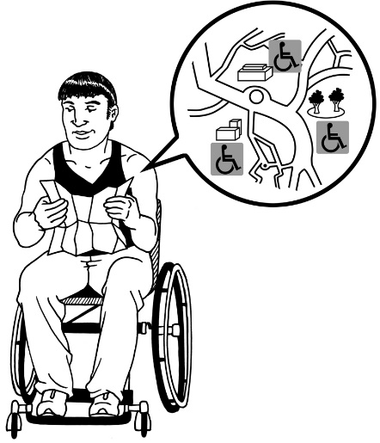

It is near:
Circa Theatre
Te Papa museum.

Accessibility at the conference

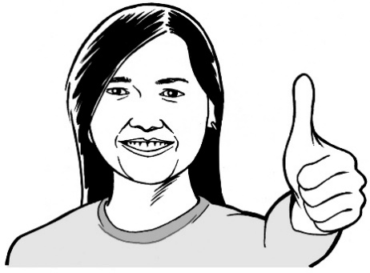
We are doing our best to make the conference accessible to everyone.

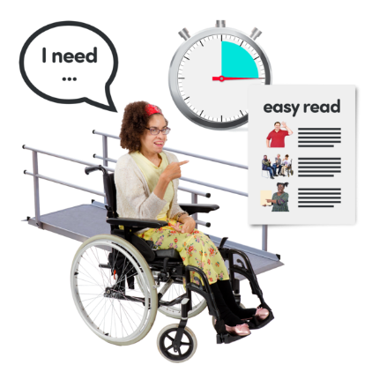
Accessible means the conference is planned in a way that makes it easier for disabled people to go to the conference.

We have asked the speakers to:
talk in ways that are easy to understand
make their talks useful for both:
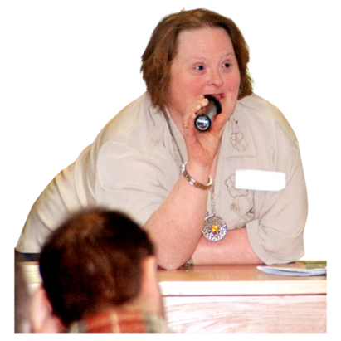
- people with intellectual disabilities
- people without intellectual disabilities.
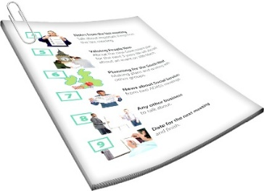
Printed programmes will be available including Easy Read copies.
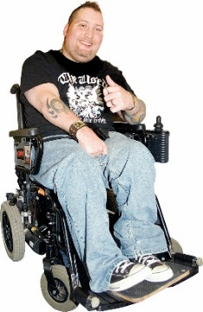

The place we are having the conference is wheelchair accessible.

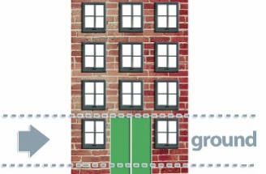
Some parts of the conference will be on the ground floor.

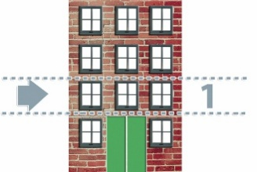
Some parts will be on level 1.

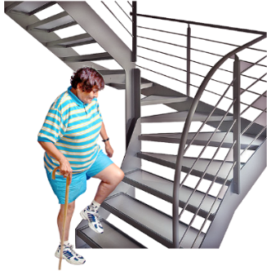
You can get to level 1 by:
stairs
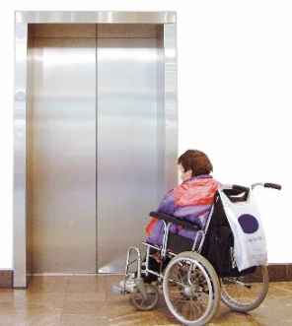
a lift.


If you need to find somewhere quiet:
the entrance area will be quiet when the talks are happening
the rooms the talks happen in will be quiet during the breaks
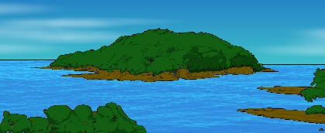
you can go outside to the waterfront.

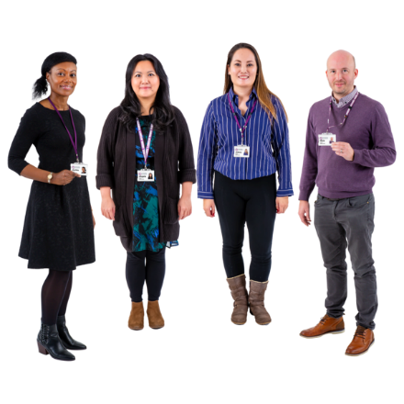
There will be people from ASID who can support you to find:
a quiet space
the room for the next talk.
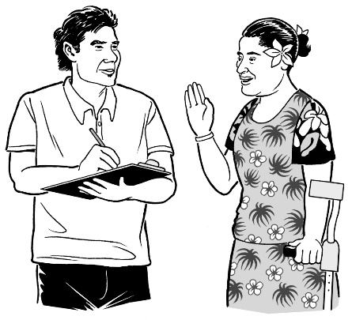

We hope you will tell us what we can do to make things more accessible.

How much does the conference cost?

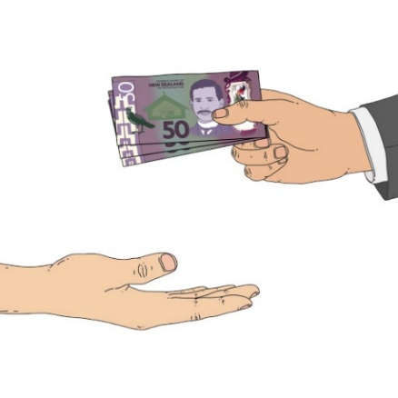
This is how much you need to pay to go to the conference:
1 hundred dollars if you are a member of ASID
1 hundred and 50 dollars if you are not a member of ASID

25 dollars if you:
- who have lived experience of disability
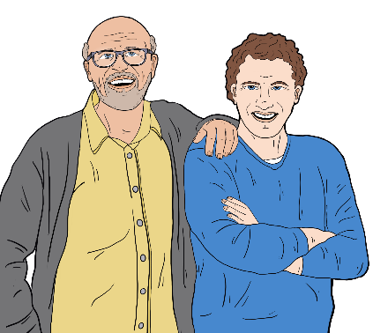
- are a family member of someone with lived experience of disability

- are at the conference to support a person with lived experience.
Paying to go to the conference means you can:
go to any of the conference talks
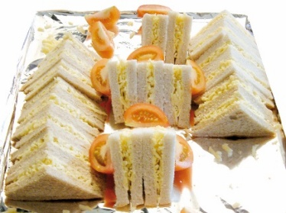
have morning / afternoon tea
have lunch
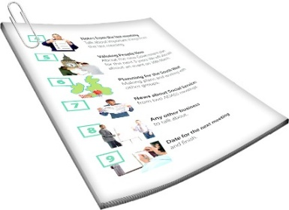
get a printed programme
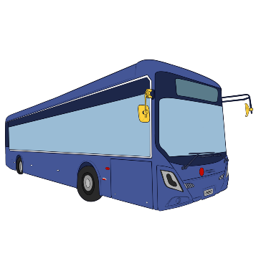
get a name sticker to wear while you are at the conference.

You will need to pay for things that are not part of the conference like:
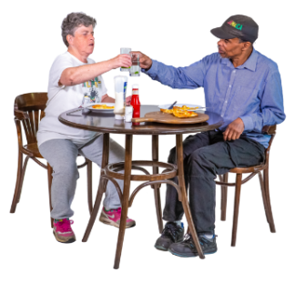
travel / transport
other meals

a place to stay if you need one.

How do I sign up for the conference?

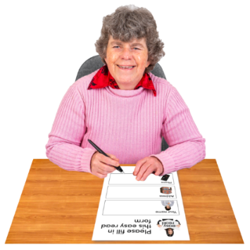
If you want to go to the conference you need to sign up first.

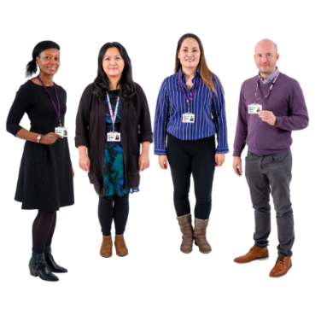
This is so the people running the conference know you are coming.


You can sign up online at:
https://bit.ly/4gyr0RG


You can also sign up by sending an email to ASID at:

info@asid.asn.au


If you send an email you should tell us your:
name

contact details like phone / email address
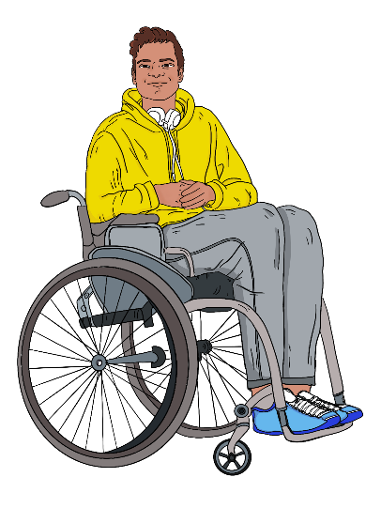
dietary requirements
support needs like:
- if you use a wheelchair
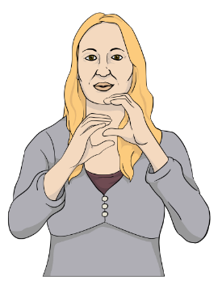
- if you need a sign language interpreter
- any other support needs.


Dietary requirements means food you cannot eat like if you:
are vegetarian
need halal food.

You should also say if you are:

a person with lived experience of disability
a family member

a support person
a professional.

If you will have a support person at the conference:
you need to tell us when you sign up
your support person also needs to sign up.

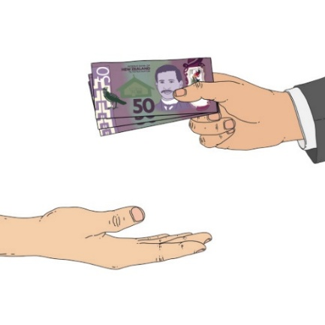
We will email information on how to pay after you have registered.


You can then pay the money to ASID by internet banking.

How do I get to the conference?


There are different ways you can get to the conference.

You might choose to:
drive

catch a bus then walk from the bus stop
get a taxi or Uber
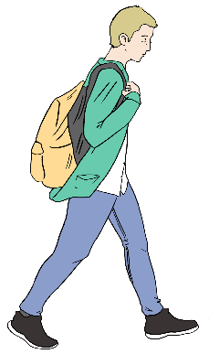
walk if you are close.

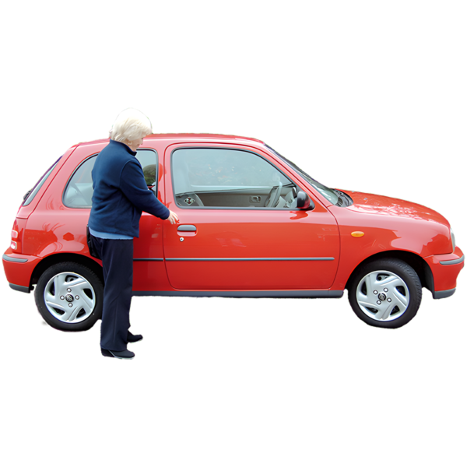
If you are driving there are 2 carparks nearby:
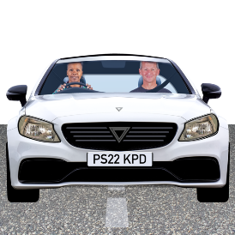
Barnett Street carpark:
- is on the corner of Barnett Street and Cable Street


- costs 20 dollars for the whole day
- is about 4 minutes walk from the conference.
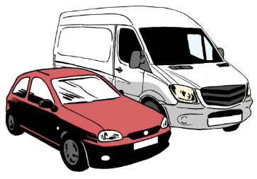
Te Papa carpark:

- is at Te Papa museum
- costs 40 dollars for the whole day
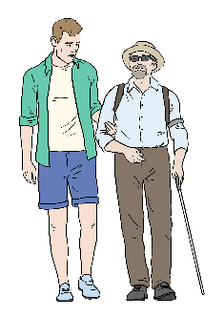
- is about 3 minutes walk from the conference.

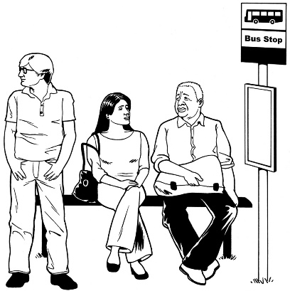
Most buses stop on either:
Courtney Place
Willis Street.

It is about 10 minutes walk from these stops to the conference.

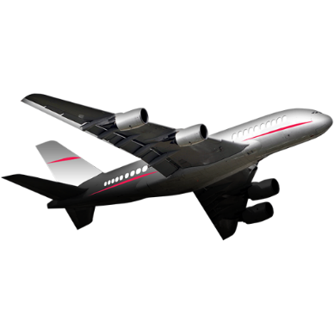
The Airport Express bus from the Airport also stops on Courtney Place.

You can find more information about buses on the Metlink website at:

www.metlink.org.nz

The biggest taxi company in Wellington is Wellington Combined Taxis.

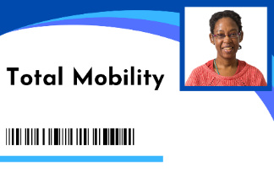
Wellington Combined Taxis accept Total Mobility cards.


You can call them on:

0800 384 4444.

Where to stay for the conference


If you need somewhere to stay near the conference you might want to look at these hotels:
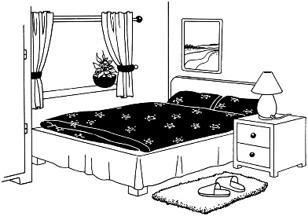
Mercure Wellington Central City Hotel – about 10 minutes walk from the conference
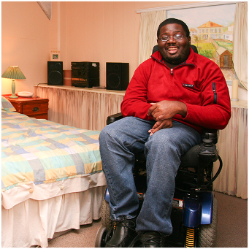
Oaks Wellington Hotel – about 6 minutes walk from the conference
U Residence Hotel – about 3 minutes walk from the conference
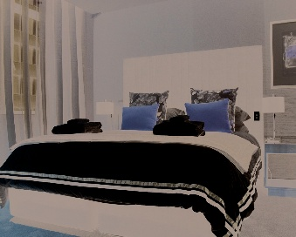
QT Wellington – about 4 minutes walk from the conference.

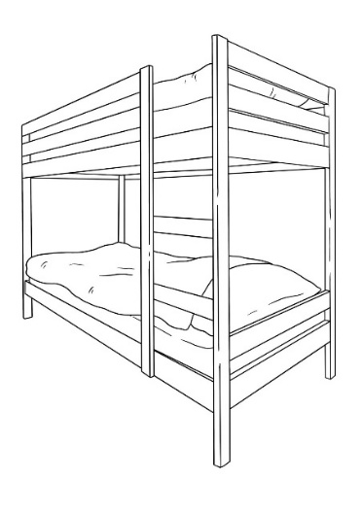
There is also a hostel called Haka House Wellington which is about an
8 minute walk from the conference.

A hostel is a place that:

is sometimes cheaper than a hotel
lets you book a bed in a room that other people can also book beds in

has things you share with other people like:
- kitchens
- bathrooms.

More information

You can find more information at:

https://bit.ly/4gyr0RG


You can also email us at:

info@asid.asn.au

This information has been written by ASID Aotearoa New Zealand.

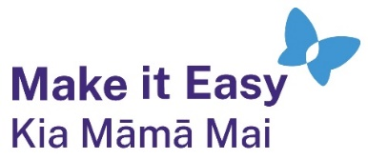
It has been translated into Easy Read by the Make it Easy Kia Māmā Mai service of People First New Zealand Ngā Tāngata Tuatahi.

The ideas in this document are not the ideas of People First New Zealand Ngā Tāngata Tuatahi.

All images used in this Easy Read document are subject to copyright rules and cannot be used without permission.


Make it Easy uses images from:


- Photosymbols

- Change Images


- Huriana Kopeke-Te Aho

- SGC Image Works

- T Wood


- Studio Rebeko

- Inga Kramer.

